Feminist Film

Gloria Galindo (University of California-Santa Barbara)

There is not a consensus about what “feminist film” is. A simple definition would be films about women made by women that advance the feminist cause. An early example of the type is The Smiling Madame Beudet (1922) [La souriante Madame Beudet] – an impressionist, silent tale of a woman’s psychological and physical confinement. It was directed by Germaine Dulac, the main woman filmmaker in 1920s French avant-garde cinema. However, some critics also consider feminist those films that have a female protagonist or deal with women’s matters, regardless of the filmmaker or screenwriter’s gender, as is the case with Thelma and Louise (1991) directed by Ridley Scott. This view contrasts with the practice of film festivals and distributors. The distributor Women Make Films, for example, relies nearly exclusively on female directors, and the London Feminist Film Festival programs exclusively films by women that deal with feminist issues or are feminist in their representation of women.

From a formal perspective, some critics refer to two forms of feminist film. One is a realistic or documentary narrative describing the conditions of women under the ruling patriarchal system. A second category, inspired by post-structuralism and the French feminist school, mistrusts documentary and traditional narrative codes, since they are implicitly underpinned by a masculinity ideology that has historically subjugated women. This second type of feminist film favours formal experimentation, rejects the codes of realism and the patterns of conventional storytelling, and tries to destabilise received modes of framing and continuity editing in an attempt to bypassing conventional male-centred semantics.

In an attempt to destabilise dominant meaning-making strategies, feminist film has made use of a different grammar from that utilised by the mainstream cinema. Feminist theorist Luce Irigaray has pointed out that the function of feminist discourse is to “[t]urn everything upside down, inside out, back to front. Rack it with radical convolutions, carry back, reimport, those cries that [a woman’s] body suffers in her impotence to say what disturbs her. Insist also and deliberately upon those blanks in her discourse which recall the places of her exclusion and which, by their silent plasticity, ensure the cohesion, the articulation, the coherent expansion of established forms.” (142)

A film that abides by such an imperative, and by now a canonical feminist film, is Riddles of the Sphinx (1977) directed by Laura Mulvey, author of the seminal essay “Visual Pleasure and Narrative Cinema” and a pioneer in feminist film theory and film studies. Riddles of the Sphinx, made in collaboration with Peter Wollen, is an attempt to yoke feminist thought and formal experimentation in order to create a feminist language that denounces the arbitrary nature of conventional film techniques, unable to represent women’s language and conflictive location in patriarchal society.

Having departed from the understanding of spectatorship as gendered and at the service of the male eye, which fetishized the female body and disempowered women, feminist cinema has developed more and more toward narrative film since the turn of the 21st century. Teresa de Lauretis observes in Technologies of Gender (1987) that feminist film tends to create “narratives strategies, points of identification, and places of the look that may address, engage, and construct the spectator as gendered subject,” as in the case of Born in Flames (1983) directed by Lizzie Borden.

Born in Flames is a documentary-style feminist futuristic film that explores racism, classism, sexuality, and political conflicts in a utopian United States socialist democracy. The significance of Borden’s film is the understanding that “the female subject is en-gendered, constructed and defined in gender across multiple representations of class, race, language, and social relationship; and that, therefore, differences among women are differences within women” (139). The film addresses the spectator “as female in gender and multiple or heterogeneous in race and class,” and shows images of “unaestheticized” women. The female body is not fetishized through masquerade but “consciously de-aestheticized,” in order to “signal the deconstruction or the destructuring, if not destruction, of the very thing to be represented,” subverting the idea of female beauty, which gives it a “documentary quality” (144-45).

There are other examples of feminist film of colour from around the world that have gained international recognition, such as Iranian film director, screenwriter, and producer Tahmineh Milani who was imprisoned in 2001 for her film The Hidden Half (2001). Mexican-born Chicana director, producer, and writer Lourdes Portillo is best known for Señorita extraviada [Missing Young Woman] (2001) a documentary film on the killings of hundreds of young women in the border town of Ciudad Juarez, Mexico. Deepa Mehta is an Indian-born Canadian writer and director, and one of the most internationally renowned woman filmmakers. Her body of work—such as the trilogy Fire (1985), Earth (1988), and Water (2000)—often addresses conflicts arising from the clash between individual desires and tradition. African American Gina Prince-Bythewood is a film and TV director, writer, producer, and actor. She directed Love and Basketball (2000), a feature-length film about the struggles of a woman basketball player, Disappearing Acts (2000), and episodes of television series.

The subversive assumption of a female spectator and the unfetishized body in new feminist film is in fact, a “film-theoretical paradox,” since “in film theory the female is constructed precisely as fetish or masquerade” (Lauretis 145). However, for Lizzie Borden, echoing Luce Irigaray’s discourse, “[t]he important thing is to shoot female bodies in a way that they have never been shot before” (145). Feminist film and films by filmmakers of colour in particular, examines not just gender but race, ethnicity, and class issues, giving voice to the experiences of women who are seldom seen or heard in mainstream films. Through its experimental vocation and its attempt to articulate excluded and underrepresented social experience, feminist film dovetails with the most radical formal and political modernist impulses.

References and Further readings:

Irigaray, Luce. (1994). Speculum of the Other Woman. Trans. Gillian C. Gill. Ithaca: Cornell UP.

Lauretis, Teresa de (1987). Technologies of Gender: Essays on Theory, Film, and Fiction. Indianapolis: Indiana UP.

Mulvey, Laura (1999). “Visual Pleasure and Narrative Cinema.” Film Theory and Criticism: Introductory Readings. Eds. Leo Braudy and Marshall Cohen. New York: Oxford UP, 833-44.

Paratextual Materials:

agnès films: a community of women filmmakers: http://agnesfilms.com/category/interviews/

Bechdel Test Movie List: http://bechdeltest.com/

Born in Flames (1985): http://youtu.be/KgUU41D4T7g

Laura Mulvey and Peter Wollen: http://www.luxonline.org.uk/artists/laura_mulvey_and_peter_wollen/essay(1).html

London Feminist Film Festival: http://londonfeministfilmfestival.com/

Riddles of the Sphinx (1977): http://www.wmm.com/filmcatalog/pages/c471.shtml

Riddles of the Sphinx (1977): http://youtu.be/-9u5md4QjF0

The Smiling Madame Beudet (1922): http://houseofmirthandmovies.wordpress.com/2008/12/10/the-smiling-madame-beudet-dulac-1923/

The Smiling Madame Beudet (1922): http://youtu.be/1wJLQN4uajE

Women of Color Filmmakers: http://blog.lib.umn.edu/raim0007/wost3307/4_women_of_color_filmmakers/

Women Makes Movies: http://www.wmm.com/index.asp

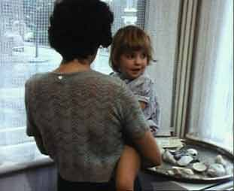
Still from Riddles of the Sphinx (1977)

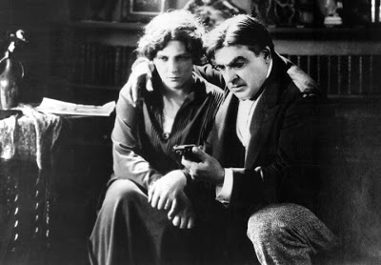

Still from The Smiling Madame Beudet (1922)

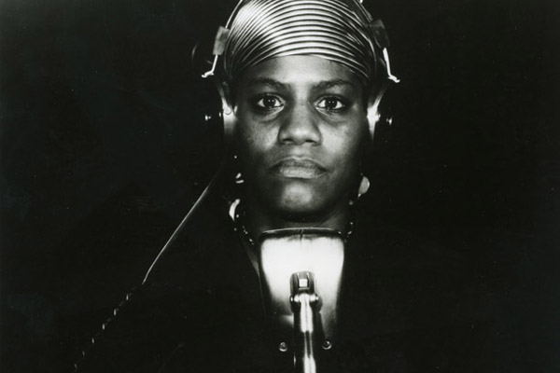

Born in Flames (1985)

